Spark Streaming

Step-1 sparkstream.py program
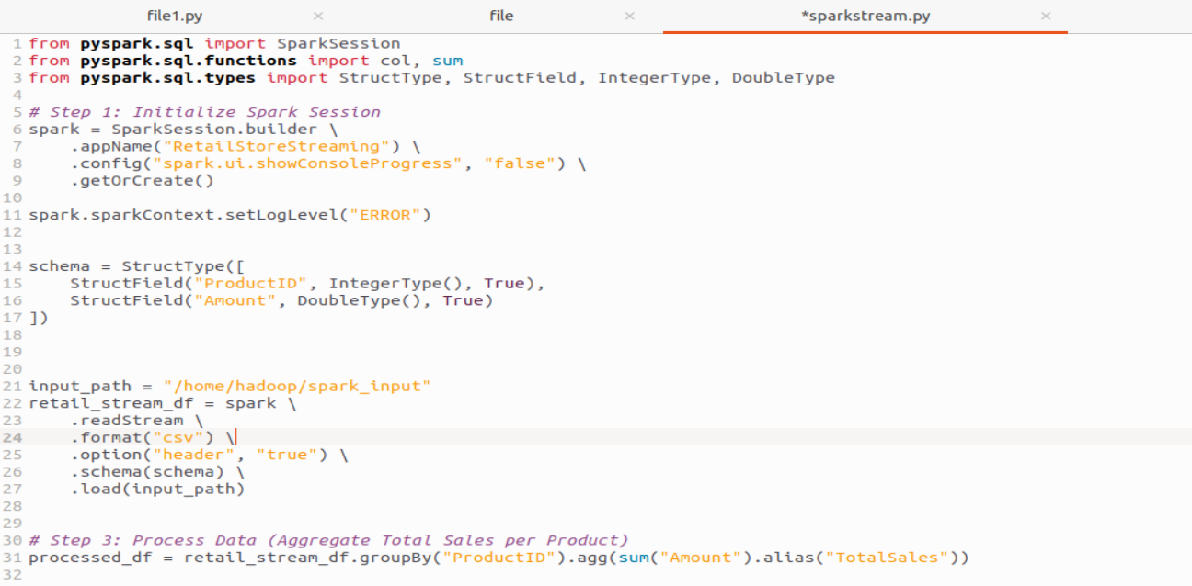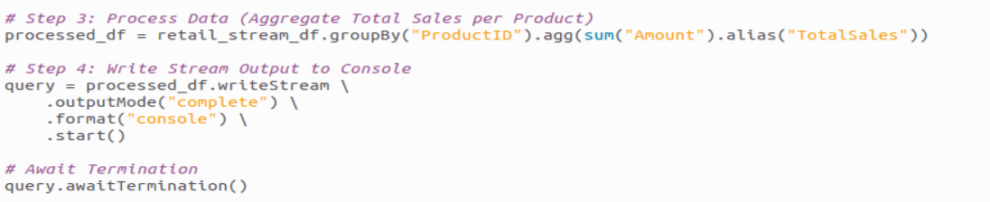
Step-2 – Create input file
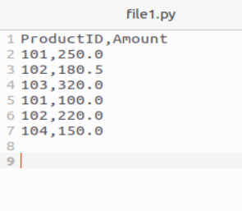
Step-3 Run using the following command

Output
